Name:_________________________________________________________________________________________
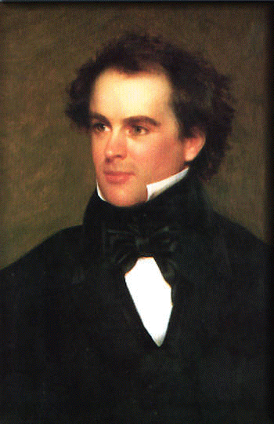
Use the following websites to research and answer questions on Nathaniel Hawthorne, the author of The Scarlet Letter.

Hawthorne Biography

Women in Hawthorne

Romanticism

Allegory/Hawthorne

- During what era in American History was Nathaniel Hawthorne born? (What was happening in America) | 5. Where is Hawthorne’s body buried? What is significant or cool about that cemetery (you may need to Google that cemetery to figure that out)?
2. What characteristics of Hawthorne’s writing made him a literary star (leading writers of the time)? | 6. What is Romanticism? What are characteristics of romantic writing and why would Hawthorne be considered a “Romantic” writer?
3. Why was it appropriate the Hawthorne wrote avidly about the Puritan existence? | 7. Briefly describe the relationships between Hawthorne and the women in his life. How have they influenced Hawthorne?
4. Which great author dedicated Moby Dick to Hawthorne? | 8. What is the purpose of allegories in Hawthorne’s writing?

